ST. ERVAN PARISH COUNCIL
Jacqui Peskett
Parish Clerk

Email: stervanpc@outlook.com
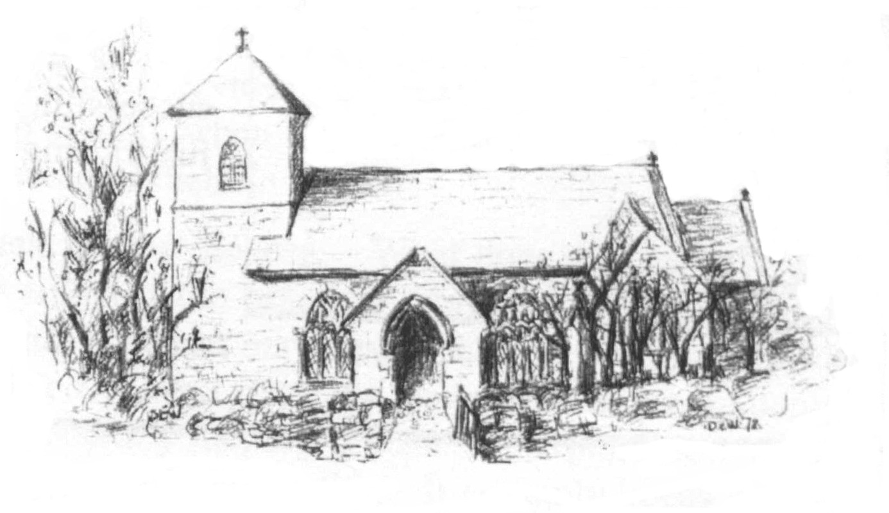

23rd February 2024

I hereby give notice that the ORDINARY MEETING of ST ERVAN PARISH COUNCIL will be held at St Ervan Village Hall on Tuesday 5th March following the Annual Parish Meeting which starts at 7pm.

All members of the Council are herby requested to attend for the purposes of considering and resolving upon the business about to be transacted at the meeting as set out in the agenda.

Jacqui Peskett
Clerk/RFO to St Ervan Parish Council

Public Participation
AGENDA

Apologies and Announcements

Declarations of interest

Minutes of St Ervan Parish Council Meeting 2nd January 2024

Matters Arising & Correspondence

Planning Applications

Non Material Amendment (1) to Application No. PA22/07877 dated 21st December 2022 for Alterations to the external and internal space within a newly built light Industrial shed to create space for training, meeting, break out space, storage for vehicles, craft and equipment. Additional items include a new septic tank/interceptor and a new wash down area for hosing down equipment and vehicles, namely, to change new windows in the elevations from grey powder coated aluminium frames to white Upvc window frames
Planning Application
RNLI Former NAAFI 3 The Old Airfield St Merryn Padstow Cornwall PL28 8PU
Ref. No: PA24/0054 -considered by email and SUPPORTED 23rd February 2024

Proposed Repowering of Bears Down Wind Farm with five wind turbines and associated infrastructure including access tracks, electrical housing, underground cabling and temporary construction hardstanding areas.
Planning Application
Bears Down Wind Farm St Eval Wadebridge Cornwall PL27 7TA
Ref. No: PA23/10324 – to be discussed at the meeting held on 5th March 2024

Items for Information

Highways

Finance

Date Of Next Meeting: Tuesday 7th May @ 7.30pm

